# **HealthAI: Intelligent Healthcare Assistant Using IBM Granite**

# **Project Report**

## **1. INTRODUCTION**

### **1.1 Project Overview**

HealthAI is an intelligent application designed to unify symptom tracking, AI-powered insights, wellness tips, and reminders into a single, secure platform aimed at improving user self-care and health management.

### **1.2 Purpose**

The project’s goal is to enhance proactive healthcare behaviors by providing accurate, personalized guidance and secure tracking, particularly for users struggling with fragmented tools or limited healthcare access.

## **2. IDEATION PHASE**

### **2.1 Problem Statement**

Users face challenges with multi-app health management, generic advice, and data privacy concerns. HealthAI addresses these issues with a trustworthy, all-in-one assistant.

### **2.2 Empathy Map Canvas**

**Persona: Busy Adult**

* **Think & Feel:** Consistently worried about missing symptoms and overwhelmed by fragmented tools.
* **See:** Confusing notifications from multiple health apps.
* **Say:** “I just want one reliable place to track this.”
* **Do:** Attempts to log symptoms but often forgets.
* **Pain:** Neglected health due to inconsistent tracking.
* **Gain:** A single, empathetic platform for health tracking.

### **2.3 Brainstorming**

Key ideas generated included voice-optimized text input via Gradio, Watson-powered conversational AI, context-aware reminders, and secure de-identified logs for user privacy.

## **3. REQUIREMENT ANALYSIS**

### **3.1 Customer Journey Map**

1. **Onboarding:** Download app → register → verify
2. **Symptom Entry:** Text/image input → AI analysis
3. **Guidance:** Wellness tips and home remedies
4. **Reminders:** Set and receive alerts
5. **Retention:** Repeated use, tracked progress

### **3.2 Solution Requirements**

* Multi-channel symptom input (text, image)
* AI-generated condition suggestions + guidance
* Personalized wellness programs and remedies
* Robust reminder system
* Secure authentication and encryption

### **3.3 Data Flow Diagram**

1. User interacts via Gradio → 2. Sent to Flask backend → 3. Analyzed via Watson Assistant & custom ML → 4. Results stored and returned to UI → 5. Reminders executed via scheduler

### **3.4 Technology Stack**

* **UI:** Gradio (Python)
* **Backend:** Python (Flask/FastAPI)
* **AI/ML:** scikit-learn, Watsonx.ai
* **Conversational AI:** IBM Watson Assistant
* **DB:** SQLite/MySQL via SQLAlchemy
* **Deployment:** Docker on IBM Cloud

## **4. PROJECT DESIGN**

### **4.1 Problem–Solution Fit**

HealthAI mirrors user behaviors by enabling direct symptom logging (text/image) and delivering empathetic AI responses and reminders through a single interface.

### **4.2 Proposed Solution**

A secure, intuitive platform merging symptom logging, condition insight, wellness guidance, reminders, and data privacy—all powered by Python and IBM Watson.

### **4.3 Solution Architecture**

* **UI layer:** Gradio chatbot & forms
* **Backend layer:** Python API microservices
* **AI layer:** IBM Watson Assistant
* **Storage layer:** Database + file storage
* **Scheduler:** Python-based reminder engine

## **5. PROJECT PLANNING & SCHEDULING**

### **5.1 Project Planning**

* Two 6-day sprints (Jun 12–17, Jun 19–24) with consistent completion of 12 story points per sprint
* Sprint targets: Registration, symptom input, AI integration, reminders

## **6. FUNCTIONAL AND PERFORMANCE TESTING**

### **6.1 Performance Testing**

* Response time < 2 s
* 50+ concurrent requests handled
* OAuth2 authentication, TLS encryption, and error resilience

## **7. RESULTS**

### **7.1 Output Screenshots**

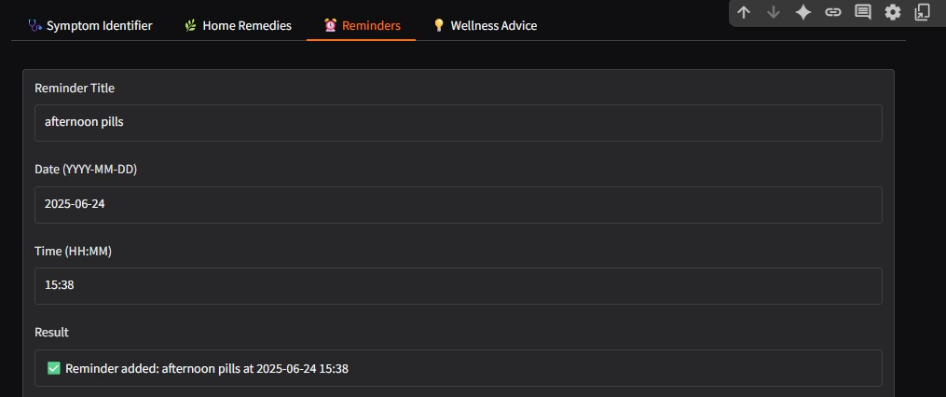

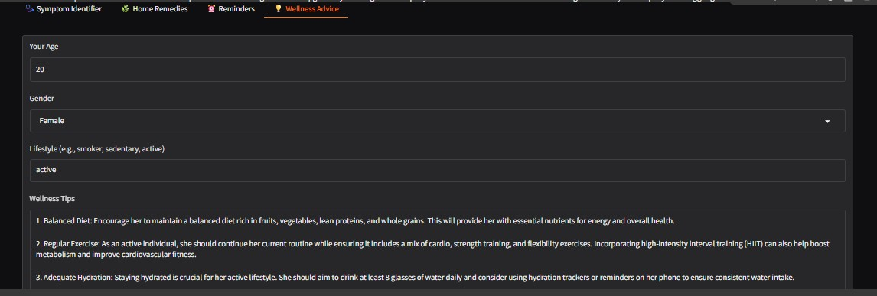

## **8. ADVANTAGES & DISADVANTAGES**

**Advantages:**

* All-in-one health toolkit
* Empathetic AI, secure data handling
* Quick deployment with open-source + IBM tools

**Disadvantages:**

* Occasional latency in AI responses
* Limited voice input and language support

## **9. CONCLUSION**

HealthAI delivers a cohesive, secure, and personalized health management experience that aligns with user habits and promotes consistent care.

## **10. FUTURE SCOPE**

* Add voice and multilingual support
* Integrate wearable device data
* Develop admin dashboards for oversight
* Refine AI with explainability and ethical oversight

## **11. APPENDIX**

* **Source Code:** *GitHub link:*

*https://github.com/YasaswiTumma/HealthAI-Intelligent-Healthcare-Assistant-Using-IBM-Granite*

* **Dataset Link:** *Provide data sources if any*
* **Demo:** *demo link:*

*https://drive.google.com/file/d/1k6RupLtBK1MQOdGoAQxhloFtpHUtD4-L/view?usp=drivesdk*